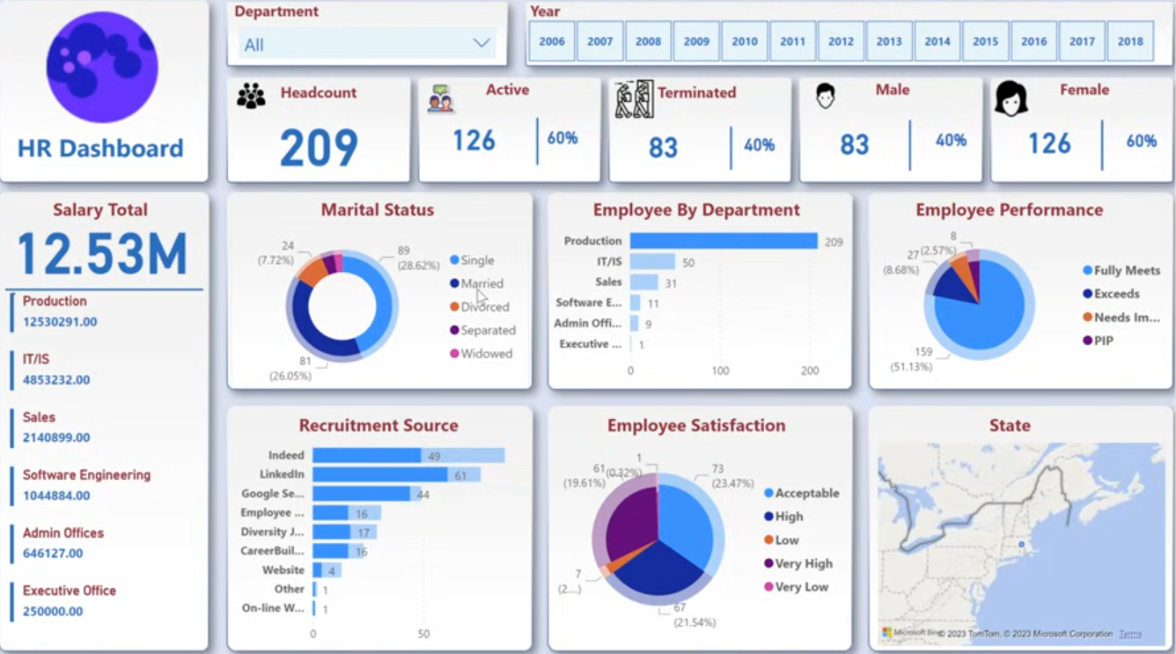
- Create the background for the dashboard view using power point and then open the power BI and then upload the background
- Want to change any colours we can do it
- After that add the text box for dashboard title and also add the log (using the insert imager and then going through the formatting section)
- Then add a text box and slicer for adding the department slicer
- And to provide the year level slicer, we need to create a year column form the HRData using the hire date column
- And do the formatting as in the image
- And then add the text as title to all the remaining sections also as shown in the image
- now as we need to show so many KPI’s like head counts, active , inactive and so on, we will create new measures and columns
- So to this click and enter data section on top in Home and name it as “All Measures”
- Now in that add one new measure for that “Head Count = COUNTROWS(HRData)”
- Now will add the active employees count→ to do that will go the “EmployeementStatust” column and click on the group and then create two group one as Active and another one as Terminated
- Cross check by looking at table view
- And then rename the newly create column as the “Status”
- Now go back to the view and now we have to show the active employees so create a new measure in “All Measures” table
- Active = CALCULATE([Head Count], HRData[Status] = "Active")
- Also we have to show the % of active right, will create one more measure for showing the “Active %”
- Active % = DIVIDE([Active], [Head Count], 0)
- Add a line between these values
- Same way we have to it for the remaining KPI’s Terminated, Male, Female
- Terminated = CALCULATE([Head Count], HRData[Status] = "Terminated")
- Terminated % = DIVIDE([Terminated], [Head Count], 0)
- But the problem in here is, try to select the year 2006 then you might see some blanks so we have to set them to default as 0 , lets see how can we to that
- So change all the formulas as per the
- Active = IF(ISBLANK(CALCULATE([Head Count], HRData[Status] = "Active")), 0, CALCULATE([Head Count], HRData[Status] = "Active"))
- Repeat the same for all the measure we have created just now
- Male = IF(ISBLANK(CALCULATE([Head Count], HRData[Gender] = "M")), 0, CALCULATE([Head Count], HRData[Gender] = "M"))
- Female = IF(ISBLANK(CALCULATE([Head Count], HRData[Gender] = "F")), 0, CALCULATE([Head Count], HRData[Gender] = "F"))
- Male % = DIVIDE([Male], [Head Count], 0)
- Female % = DIVIDE([Female], [Head Count], 0)
- Now its time to add the donut chart for marital status
- → insert eh chart→ add the head count in values and marital status into label
- And then do the formatting as it in the image above
- Now add the bar chart that is employee by department
- Then do the formatting as it is in the image
- Now add the pie chart for employees by performance
- Do the formatting
- Now add a bar chart for recruitment channel
- Do the formatting
- Now we have to add the employee satisfaction chart
- I f you go to the data, we can the employee satisfaction column
- So we have to create new column by giving the tag as per the level
- Create new column in HRData→ using switch()
- 1→”Very Low”, 2→ “Low”, 3→”Acceptable”, 4→ “High”, 5→ “Very High”

